Hands on Ansible Playbook

**Sample Playbook to install httpd service and start the service.**

---

- hosts: demo

become: true

become_user: root

tasks:

- name: Demo Playbook

yum: name=httpd state=present

- name: Demo for starting service

service: name=httpd state=started

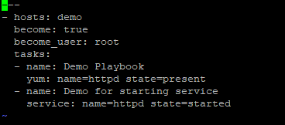

**Executing the playbook:**

ansible-playbook test1.yml --syntax-check (To check the syntax errors)

ansible-playbook test1.yml --check (To do dry run will show changes that it going to implemented but no change will happen on the remote machine)

ansible-playbook test1.yml (To execute the playbook)

ansible-playbook test1.yml -vvv ( To troubleshoot the playbook if we it fails for any version vvv(Verbose) will print everything what is happening with the playbook in the background)

Sample Playbook using tags

---

- hosts: demo

become: true

become_user: root

tasks:

- name: Demo Playbook

yum: name=httpd state=present

tags: first

- name: Demo for starting service

service: name=httpd state=started

tags: second

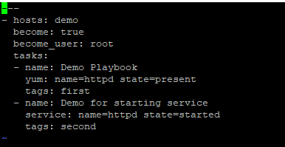

**Executing the playbook:**

ansible-playbook test2.yml --syntax-check (To check the syntax errors)

ansible-playbook test2.yml --check (To do dry run will show changes that it going to implemented but no change will happen on the remote machine)

ansible-playbook test2.yml --tags first (Executing the first tag only)

ansible-playbook test2.yml --tags second (Executing second tag only)

ansible-playbook test2.yml --skip-tags first (Skipping first tag)

ansible-playbook test2.yml --skip-tags second (Skipping second tag)

**Sample Playbook to execute bash script inside the playbook**

---

- hosts: demo

become: true

become_user: root

tasks:

- name: Copy the script file

copy: src=/home/ansible/gitinstall.sh dest=/tmp/

- name: Execute the script

shell: sh /tmp/gitinstall.sh

vi gitinstall.sh

sudo yum install -y git



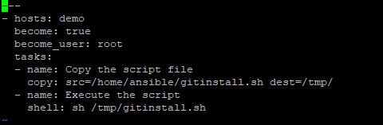

**Execution of the playbook**

ansible-playbook test3.yml --syntax-check (To check the syntax errors)

ansible-playbook test3.yml --check (To do dry run will show changes that it going to implemented but no change will happen on the remote machine)

ansible-playbook test3.yml

**Sample Playbook using replace module of ansible**

---

- hosts: demo

become: true

become_user: root

tasks:

- name: Replace the file

replace: dest=/tmp/a.txt regexp='Thursday' replace='Wednesday'

**On remote Machine**

Create file on the path /tmp by the a.txt

vi a.txt

Monday

Tuesday

Wednesday

Thursday

Friday

Saturday

Sunday

~

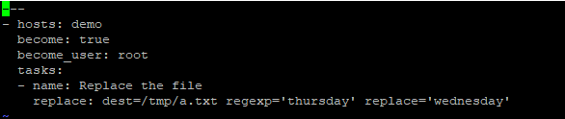

**Executing the above file**

ansible-playbook test4.yml --syntax-check (To check the syntax errors)

ansible-playbook test4.yml --check (To do dry run will show changes that it going to implemented but no change will happen on the remote machine)

ansible-playbook test4.yml

**Sample Playbook using LineInFile ansible moduel**

---

- hosts: demo

become: true

become_user: root

tasks:

- name: add the text

lineinfile: dest=/tmp/a.txt line="intellipaat" insertafter="Wednesday"

**On remote Machine**

Create file on the path /tmp by the a.txt

vi a.txt

Monday

Tuesday

Wednesday

Thursday

Friday

Saturday

Sunday

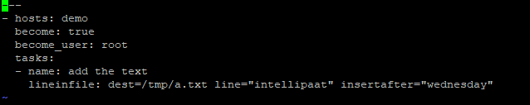

**Executing the above file**

ansible-playbook test5.yml --syntax-check (To check the syntax errors)

ansible-playbook test5.yml --check (To do dry run will show changes that it going to implemented but no change will happen on the remote machine)

ansible-playbook test5.yml

S**ample Playbook using Handlers, Variables, Yum and copy ansible modules**

---

- hosts: demo

become: true

become_user: root

vars:

srcpath: /home/ansible/index.html

destpath: /var/www/html

tasks:

- name: install httpd apache package

yum: name=httpd state=present

- name: Copy the file

copy: src={{srcpath}} dest={{destpath}}

notify: restart

handlers:

- name: restart

service: name=httpd state=restarted

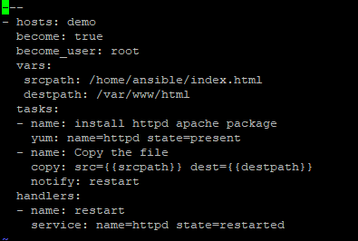

**Executing the above file**

ansible-playbook test6.yml --syntax-check (To check the syntax errors)

ansible-playbook test6.yml --check (To do dry run will show changes that it going to implemented but no change will happen on the remote machine)

ansible-playbook test6.yml

**Example to use ansible vault to encrypt decrypt and create the encrypted .yml file**

vi test7.txt

This is the file to understand ansible vault

**Executing the above file**

ansible-vault create test7.yml (To create the encrypted file)

ansible-vault encrypt test8.yml (To encrypt the file)

ansible-vault decrypt test8.yml (To decrypt the file)